EXPERIMENT 1B
PERFORMING CRISP-DM AND SEMMA

Aim :
To apply the CRISP-DM (Cross-Industry Standard Process for Data Mining) and SEMMA (Sample, Explore, Modify, Model, Assess) methodologies for systematically understanding, preparing, analyzing, modeling, and evaluating data to extract meaningful insights and support effective decision-making.

Algorithm :
- Apply the CRISP-DM framework by understanding the problem, collecting and preparing the data, building the model, evaluating the results, and presenting the findings.
- Apply the SEMMA framework by sampling the data, exploring its characteristics, modifying and preprocessing it, building the model, and assessing its performance. 3. Compare and interpret the outcomes obtained using both CRISP-DM and SEMMA methodologies.
4. Draw conclusions based on the analysis and communicate the results for informed decision-making.
Code - CRISP-DM:
- TO LOAD THE DATASET
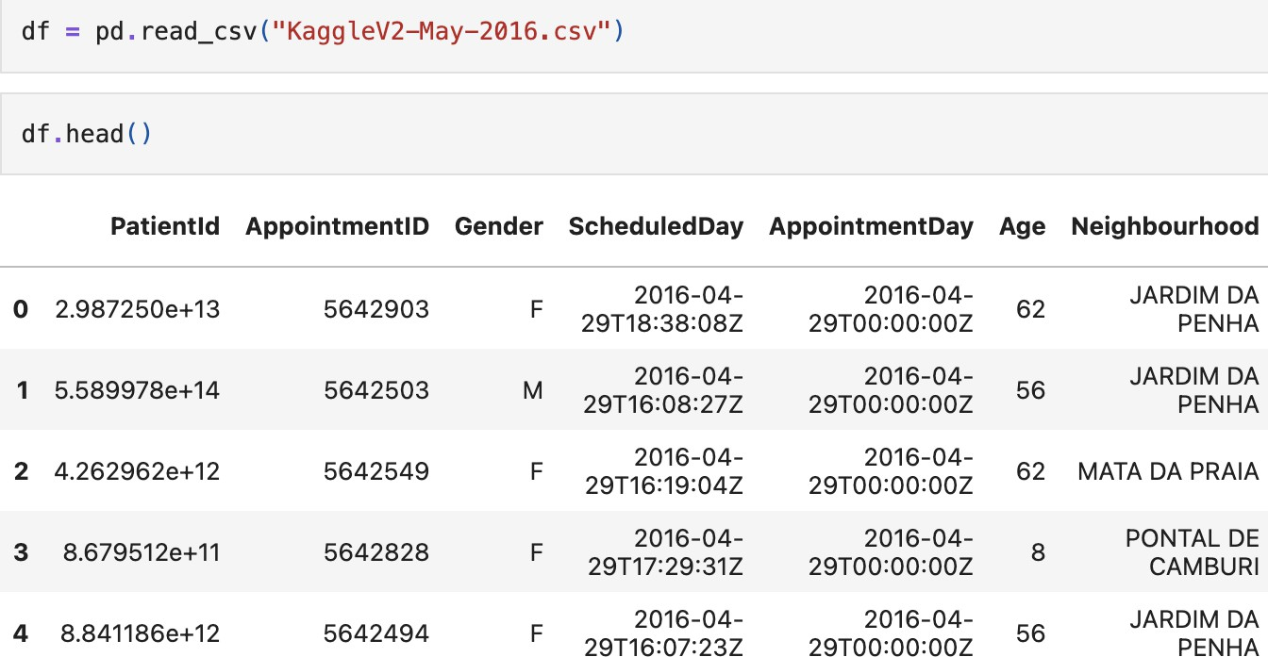

- TO PRINT TAIL AND ANALYSE SHAPE

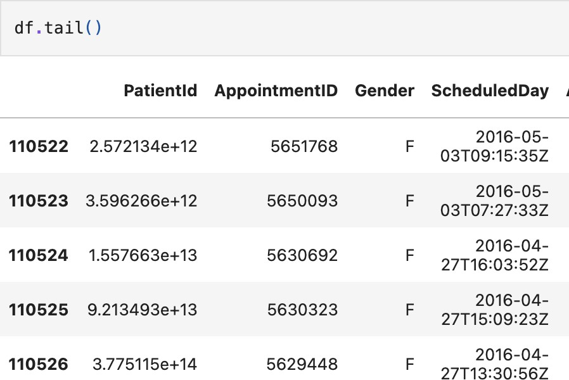

- TO PRINT INFO OF THE DATASET
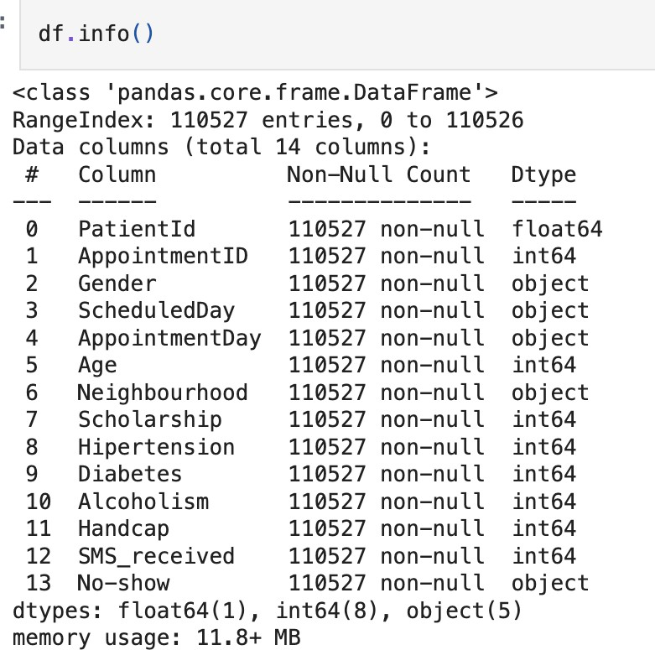

- TO PRINT COLUMN TO LIST

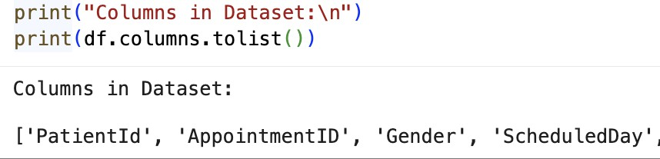

- PRINT SAMPLE

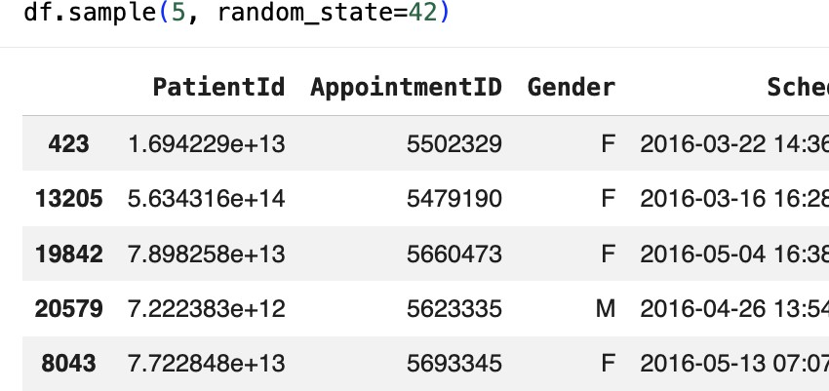

- TO DESCRIBE THE DATASET

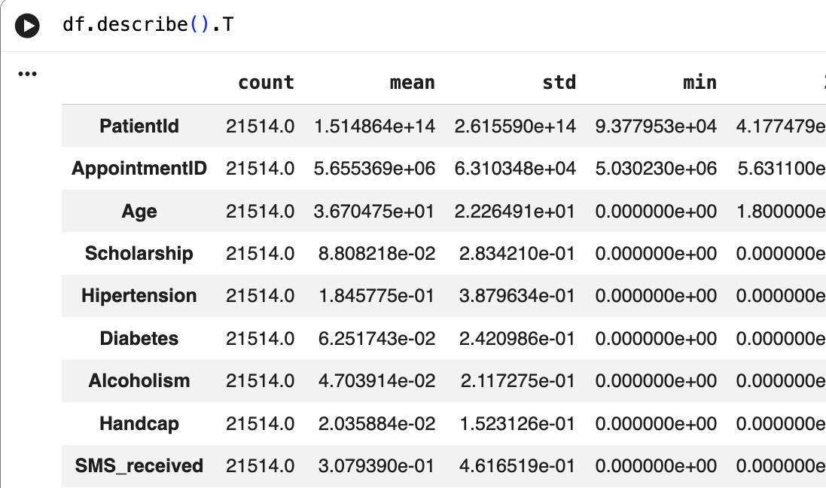

- TO ANALYSE THE MISSING VALUES

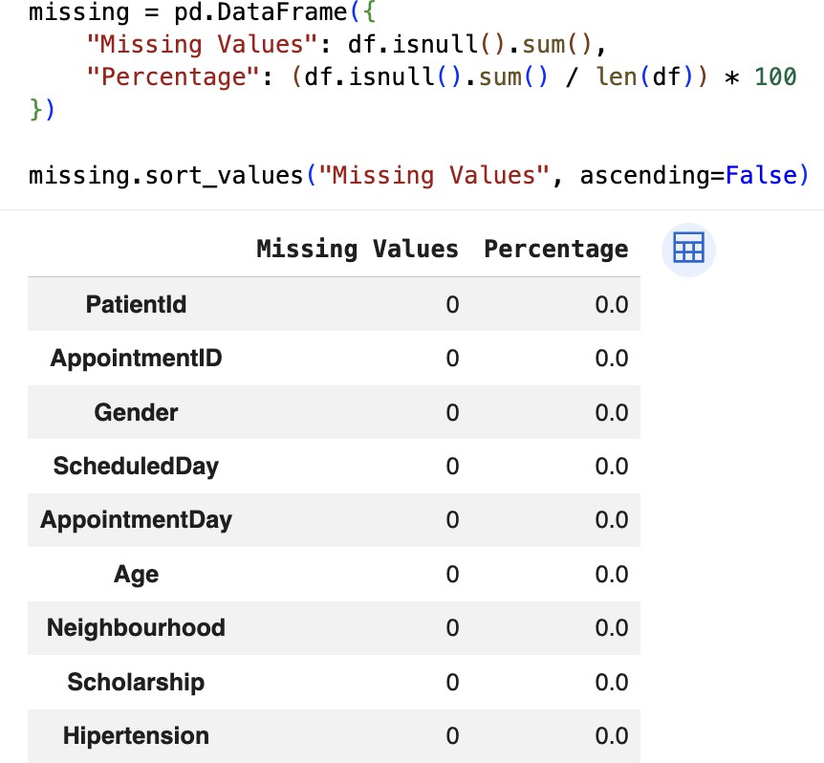
- TO PRINT DUPLICATE ROWS
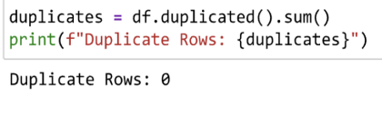
- TO PRINT UNIQUE VALUES

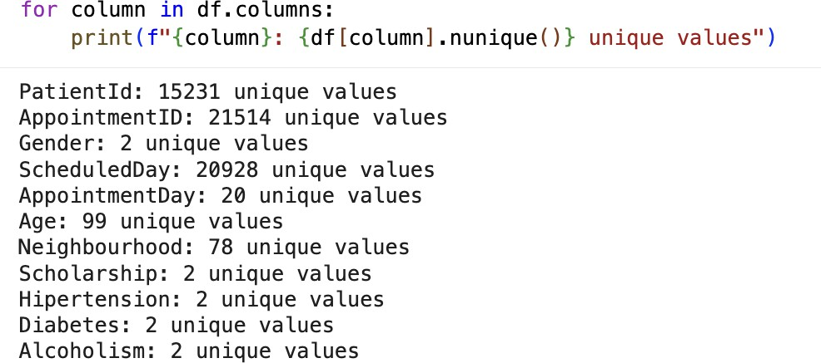

- TO VISUALISE CORRELATION MATRIX

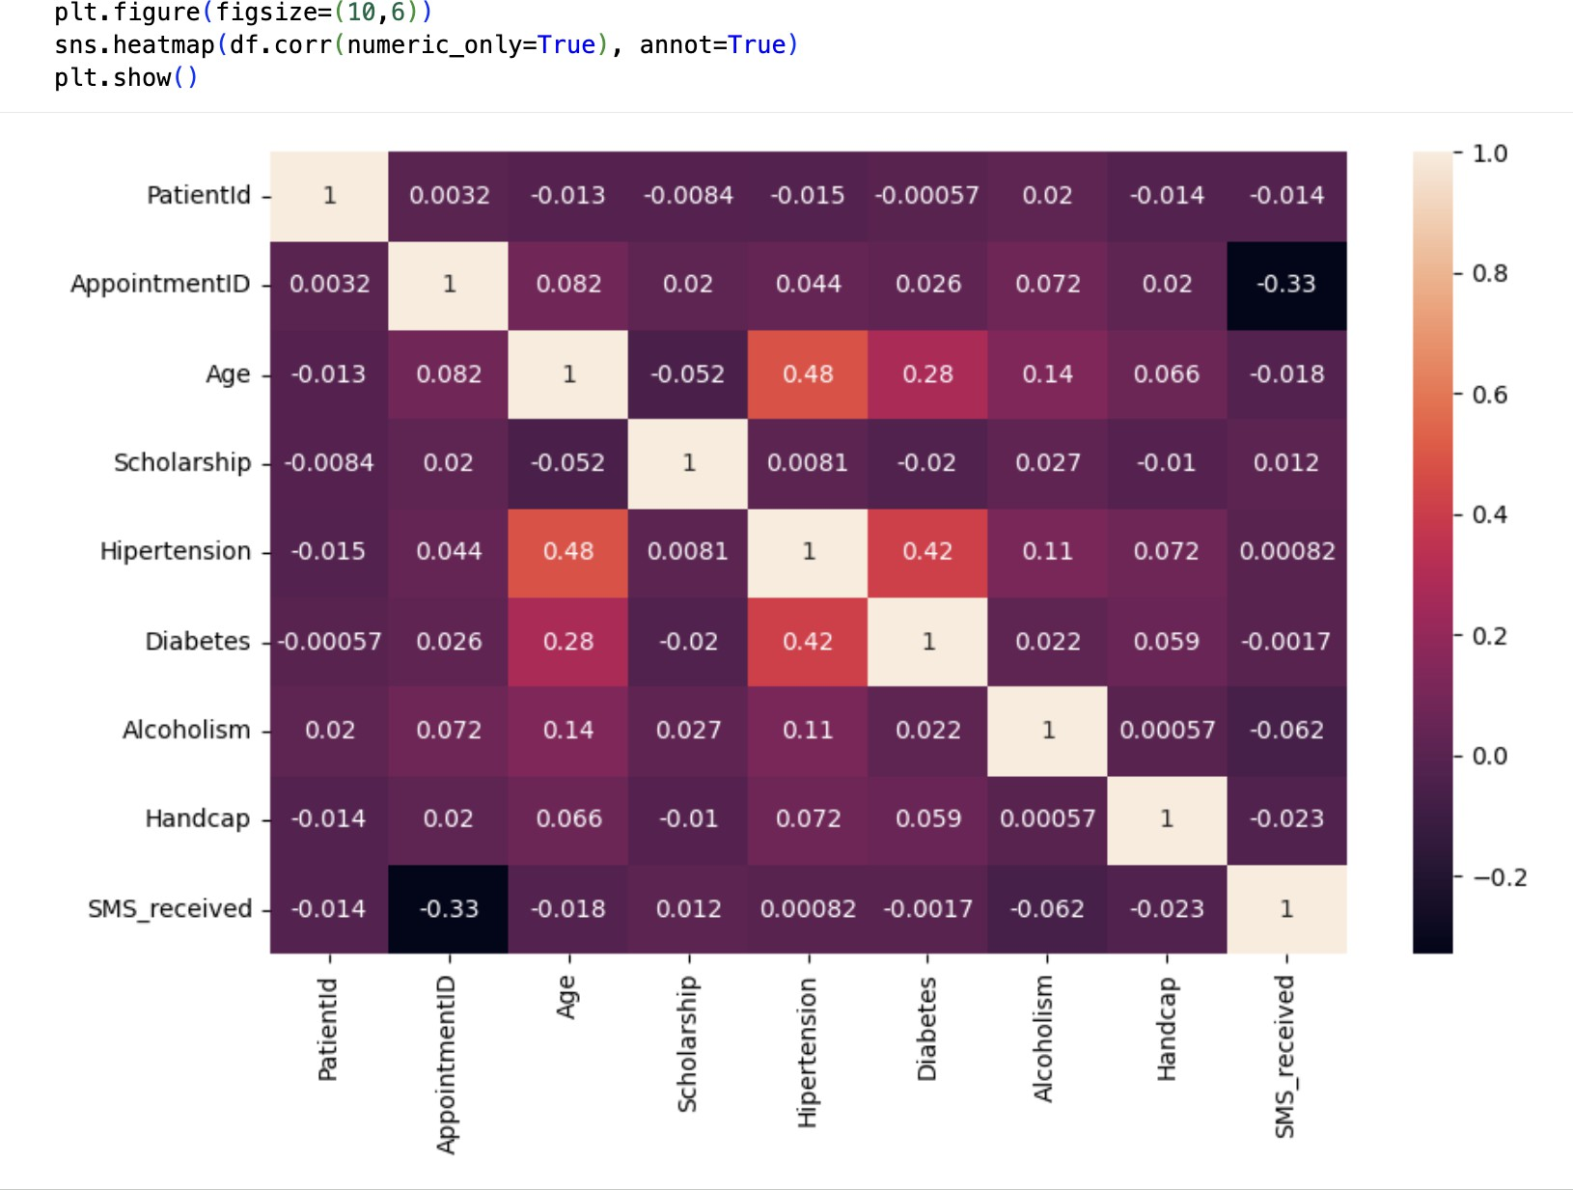

- TO ANALYSE REACH VS IMPRESSION

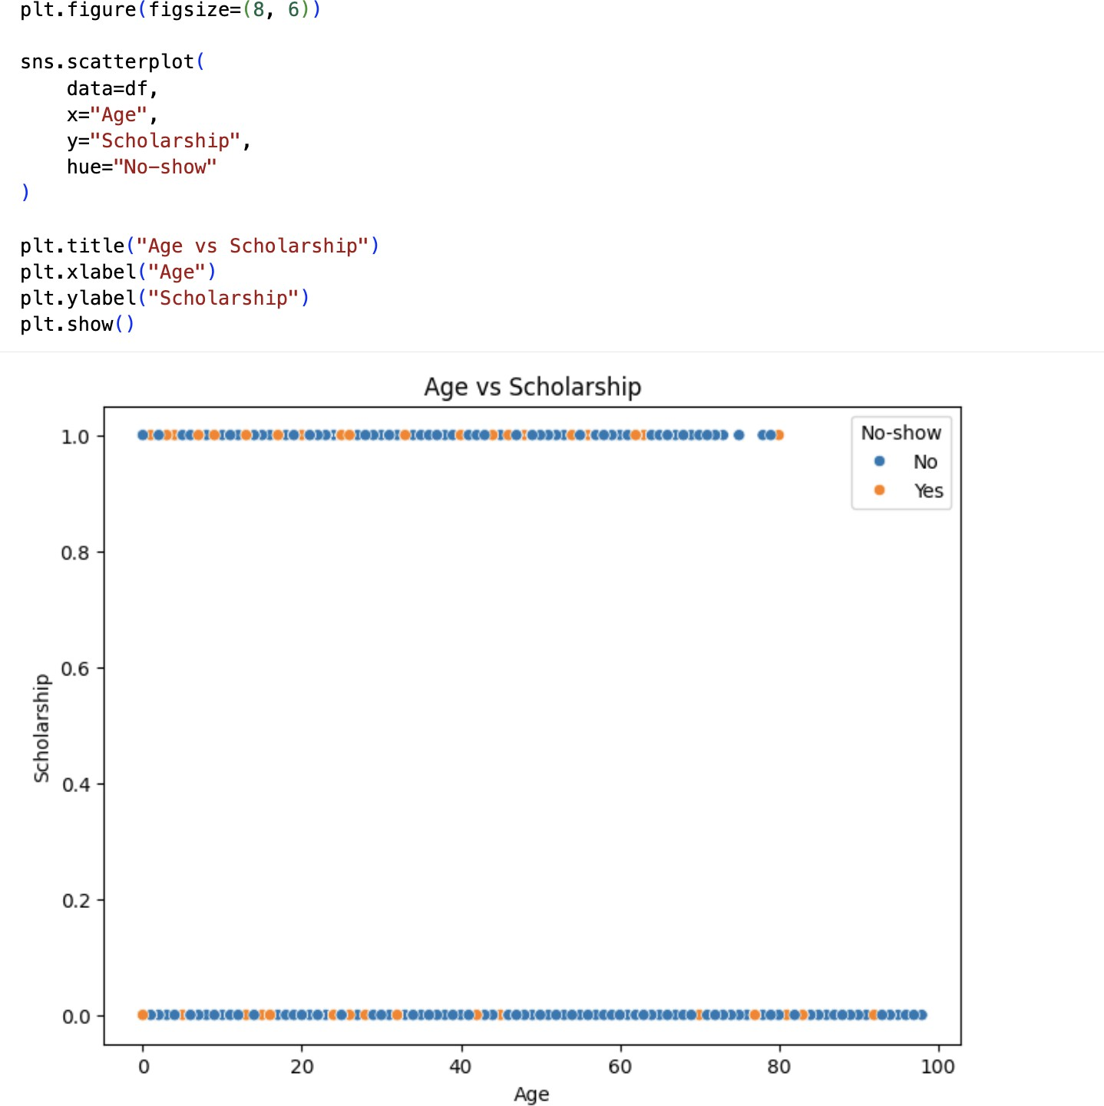
- DATA CLEANING AND PREPROCESSING
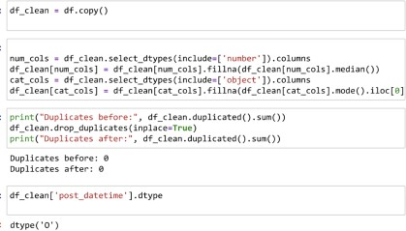
- EXTRACT DATA TIME AND CONVERTING THEIR FORMATS

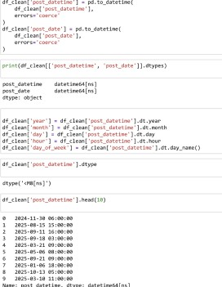
- TO
PRINT DATA TIME AFTER CONVERSION
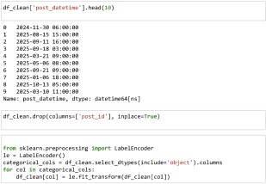
- FEATURE AND TARGET VARIABLE SEPARATION

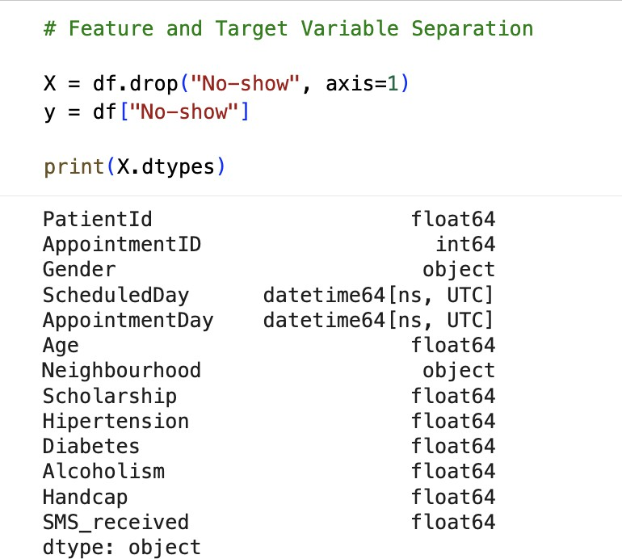

- BUILDING THE MODEL AND SPLITTING TRAIN AND TEST
- BUILDING THE MODEL AND EVALUATING ACCURACY

CODE - SEMMA :
- TO LOAD THE DATASET AND PRINT HEAD

- TO PRINT TAIL AND EXTRACT SAMPLE
- TO PRINT INFO OF SAMPLE

- TO PRINT DESCRIBE

- TO ANALYSE NULL VALUES AND DUPLICATED ROWS

- TO
VISUALISE CORRELATION MATRIX

- Performance Bucket Analysis

- TO VISUALISE SCATTERPLOT

- MODIFYING AND CLEANING THE COLUMNS

- BUILDING THE MODEL

Result :
The program to perform basic mathematical operations is completed successfully

